Pharmacological profiling of stretch activated channels in proprioceptive neurons

Shelby McCubbin, Anna Jeoung, Courtney Waterbury, and Robin L. Cooper
Department of Biology and Center of Muscle Biology, University of Kentucky, Lexington, KY, USA 40506-0225
Corresponding author: Robin Cooper, Email RLCOOP1@uky.edu

Abstract
Proprioception in mammals and invertebrates occurs through stretch activated ion channels (SACs) localized in sensory endings. In mammals, the primary organs for proprioception are the intrafusal muscle spindles embedded within extrafusal muscle. In invertebrates there are varied types of sensory organs, from chordotonal organs spanning joints to muscle receptor organs (MRO) which are analogous to the mammalian muscle spindles that monitor stretch of muscle fibers. A subset of SACs are the PIEZO channels. They are comprised of a distinct type of protein sequence and are similar among species, from mammals to invertebrates. We screened several new agents (YODA 1, JEDI 2, OB 1 and DOOKU) which have been identified to act on SACs of the PIEZO 1 subtype. YODA 1 and JEDI 2 increased activity in the crayfish MRO but not the crab chordotonal organs. The SACs of the crustacean proprioceptors have not been satisfactorily pharmacologically classified, nor have their molecular makeup been identified. We screened these pharmacological agents on model sensory organs in crustaceans to learn more about their subtype classification and compare genomic profiles of related species.
Key words: Crustacean, proprioception, SAC, sensory, stretch activated ion channels
Highlights
- Crab chordotonal organ and crayfish MRO proprioceptors examined
- Stretch activated ion channels pharmacologically screened
- YODA 1, JEDI 2, OB 1 and DOOKU had no effect on crab chordotonal organ
- JEDI 2 agent had slight effects on crayfish MRO
- Genomic screens and pharmacology suggest no PIEZO 1 SAC subtype present

Introduction
Proprioception in mammals and invertebrates occurs through stretch activated ion channels (SACs) localized in sensory endings of particular structures. In mammals, the primary organs for proprioception are the intrafusal muscle spindles embedded within extrafusal muscle. In invertebrates there are varied types of sensory organs, from chordotonal organs (Whitear, 1960), which are not embedded within muscle, to muscle receptor organs (MRO) which have endings embedded in the muscle fibers. The MRO is analogous to the mammalian muscle spindle as being comprised of sensory neurons which monitor stretch of muscle fibers (Kuffler, 1954; Swerup and Rydqvist, 1992). The classification of the SACs in the sensory neurons associated with mammal muscle spindles have recently been described as a PIEZO 2 subtype and they also have a role in sensing mechanical stimulation on skin (Chesler et al., 2016).
SACs are identified in various ways from gene/protein sequence similarities which are correlative to pharmacological profiles, but not in all cases (Boscardin et al., 2016). The reviews on classification and characterization of SACs are excellent, but one is still left without knowing which type is associated with proprioception in crustaceans (Arnadottir and Chalfie, 2010; Coste et al., 2010; Ernstrom and Chalfie, 2002; Geffeney and Goodman, 2012). The fundamental SACs are TRP channels (Transient Receptor Potential channels), DEG/ENaCs (Degenerin/epithelial sodium channels; known to be present in invertebrates and vertebrates; Geffeney and Goodman, 2012), PIEZO (pressure sensitive channel; found in plants and eukaryotic species; Coste et al., 2010) and TMC (transmembrane channels; sound and vibration-sensing hair cells in mice; Geffeney and Goodman, 2012).
Some subsets of the TRP family are blocked by ruthenium red, while the DEG/ENaC channels are blocked by amiloride (Omerbašić et al., 2015). Low extracellular pH (5.0) can activate some forms of the DEG/ENaC channels referred to as acid sensitive stretch activated channels (ASCs) (Welsh et al., 2002), and some ASCs are blocked by amiloride (Omerbašić et al., 2015). The PIEZO channels are comprised of a distinct type of protein sequence and are similar among species from mammals to invertebrates. They are now considered a novel class of ion channels involved in mechanotransduction through stretch activation (Coste et al., 2012). The mammalian form is blocked by ruthenium red while the subtype in Drosophila is not (Coste et al., 2012), and other sensory neurons within the cuticle are amiloride sensitive (Suslak et al., 2015). Gadolinium (Gd³⁺), a non-selective blocker for SACs, blocks a variety of SACs, some of which are unique in pharmacology. Relatively new agents have been identified to have action on SACs of the PIEZO 1 subtype. YODA 1 and JEDI 2 will activate PIEZO 1, and the action by YODA 1 can be reversed by DOOKU (Evans et al., 2018; Mikhailov et al., 2019; Syeda et al., 2015; Wang et al., 2018). Additionally, OB 1 can modulate activity of PIEZO 1 channels (Wetzel et al., 2017).
Furthermore, pharmacologically identifying the SACs in the MRO of the crayfish and the chordotonal organ of a crab has been attempted with the profiling of extracellular acid sensing (pH 5), ruthenium red, amiloride, and Gd³⁺. Only Gd³⁺ provided evidence of reduced activity and was reversible (Dayaram et al., 2017a,b). It was reported with preliminary studies that D‐GsMTx4 (10μM) had no effect on the crayfish MRO activity (Rydqvist et al. 2007). There is also evidence that the antibiotic streptomycin can antagonize a subset of the TRP channels (i.e. TRPM8), particularly in the cardiovascular system in mammals (Goralczyk et al., 2017). In addition, the mechanosensitive ion channel PIEZO1 is inhibited by the peptide GsMTx4 in a closed state and the streptomycin (1 mM) blocked the channel in an open state within 90 seconds of application (Bae et al., 2011). To date the SAC of the crustacean proprioceptors have not been satisfactory classified pharmacological or their molecular makeup identified. Thus, the potential action of streptomycin and the newly identified agents of YODA 1, JEDI 2, DOOKU and OB-1 were examined on proprioceptors in a chordotonal organ of a crab leg and the MRO of in the crayfish abdomen. Given that the subtype of the stretch activated channels in the chordotonal organs of the crab and the muscle receptor organ of the crayfish have not been classified with genomic profiling or pharmacological examination we hypothesized that these channels are sensitive to the novel pharmacological agents which target the PIEZO 1 subtype.
The crayfish MRO preparation continues to be used as a model of the mammalian muscle spindle due to the anatomical similarity of rapid and slowly adapting sensory neurons, as well as the motor neuron innervation of the muscle fibers maintain the fibers to be taut (Swerup and Rydqvist, 1992). The chordotonal organs in the crab leg are analogous in anatomical ultrastructure and in arrangement of sensory endings within the elastic strand as for other chordotonal organs in crustaceans and many insects (Burke, 1953; Frantsevich et al., 2019; Göpfert and Hennig, 2016; Strauß, 2017; Whitear, 1962, 1965; Wiersma, 1959). Thus, understanding the pharmacological actions on these SACs can potentially extend to numerous other model preparations in invertebrates. Being able to tweak how sensory neurons respond to muscle stretch allows one to address how neural circuits respond in a feedback loop which allows this model system to be used in novel ways for future studies. Examining the pharmacological profile along with genomic studies in a comparative nature allows an enrichment of identifying the potential of pharmacological actions on other SACs.
Methods
Animals
The maintenance of the animals used was the same as mentioned in previous reports (Dayaram et al., 2017a,b; Malloy et al., 2017; Stanback et al., 2019). In brief, both the Blue Crab (Callinectes sapidus) and Red Swamp Crayfish (Procambarus clarkii) were obtained from a distribution center in Atlanta, GA. They were then delivered to and bought from a local supermarket in Lexington, KY, USA. The crayfish (6-10 cm in body length and 12.5-25 g in body weight) were housed in individual standardized plastic containers with weekly exchanged dry fish food and oxygenated water (20-21°C). The Blue Crabs were maintained in a seawater aquarium prior to use for three to five days. All experiments were implemented in female adults with a carapace width (from point to point) of 10-15 cm. Only females were used for the blue crab as the supplier only provided female blue crabs. The crayfish were of both sexes were used. We did not use a crayfish or crabs if they were gravid, if either male or female was close to molting, or just after a molt. The crabs were fed frozen squid and the water temperature was maintained between 14-16°C. The crabs and crayfish were caught from the wild.
Similar dissection procedures and electrophysiological measures as these preparations are described in detail in text and video format (Leksrisawat et al., 2010; Majeed et al., 2013). They are also briefly described below.
Crab chordotonal organ
In brief, the animal was induced to autotomize the first or second walking leg by lightly pinching with pliers at the base of the leg. The propodite-dactylopodite (PD) chordotonal organ spans the last segment of the leg and was exposed through cutting a window of the cuticle on both sides of the leg (in the propodite segment). The leg was then pinned in a Sylgard-lined dish and covered with crab saline. The PD nerve was then exposed and pulled into a suction electrode for recording. During the experiment, the dactyl was moved from a flexed position to an open position in a 1 second time frame, held for 10 seconds, and then moved back to the starting position (Figure 1A). An insect dissecting pin was used to mark the displacement range, and each displacement was marked on the computer recording file. The crab saline used during recordings of the sensory nerves consisted of (in mM): 470 NaCl, 7.9 KCl, 15.0 CaCl_{2·}2H₂O, 6.98 MgCl_{2·}6H₂O, 11.0 dextrose, 5 HEPES acid and 5 HEPES base adjusted to pH 7.4.
Crayfish muscle receptor organ (MRO)
The dissection and recording procedures are described in Leksrisawat et al., (2010). In brief, the isolated crayfish abdomen was placed in a Sylgard-lined dish filled with crayfish saline. The MRO was moved using a wooden dowel from a relaxed position to a stretched position in a 1 second time frame, held for 10 seconds, and then moved back to the starting position. An insect dissecting pin was used to mark the displacement range, and each displacement was marked on the computer recording file. The segmental nerve to the segment of interest was pulled into a suction electrode for recording the extracellular spikes (Figure 1B).
The displacement rates were the same as for the crab PD organ. The crayfish saline used was a modified Van Harreveld’s solution (in mM: 205 NaCl, 5.3 KCl, 13.5 CaCl2ꞏ2H2O, 2.45 MgCl2ꞏ6H2O, and 5 HEPES adjusted to pH 7.4).
To insure reproducibility in experimentation for standardizing the rate of the movements, all joint movements were performed by one individual (RLC) and the activity of the PD organ was analyzed by one person (SM) while the activity of the MRO was analyzed by two people (AJ and RLC). The movements were made by physically moving the joint and counting out loud: one- Mississippi (1 sec). We timed the counting on a stopwatch several trials to be consistent in the speed of counting. The static holds were held for at least 9 seconds as monitored on the acquisition software. The velocity throughout the movement was kept as constant as possible by manual movement from the starting position to the end position for the crab PD and the crayfish MRO.

Resting membrane potential in crayfish muscle
Details of the dissection and electrophysiological recordings of the opener neuromuscular junction of the walking legs are described in video and text format (Cooper and Cooper, 2009). Intracellular recordings of the membrane potential were performed by standard procedures (Sparks and Cooper, 2004) of the most distal muscle fiber of the muscle. The preparations were monitored for 10 minutes in saline, 10 minutes in saline with DMSO and 10 minutes in saline containing YODA which was dissolved in DMSO. The concentrations of DMSO and YODA were the same as those used for the MRO preparations. Electrical signals were recorded on-line to a PowerLab/4s interface (ADInstruments, Australia) and calibrated with the Powerlab Chart software version 7.

Pharmacological agents
The concentration of DMSO (40 µl) was used to dissolve YODA 1, JEDI 2, DOOKU and OB-1 to a concentration of 48 µM in either crab or crayfish saline consistently for these agents. 40 µl of DMSO was added to 20 ml of saline to maintain the same concentration used to dissolve the agents. For examining the antagonists action of DOOKU to YODA a 5 times higher concentration (250 µM) than YODA (48 µM) was used. Since streptomycin (1 mM) is able to be dissolved in saline, DMSO was not used with the streptomycin. To exchange the bathing media to the various compounds, the bathing solution was removed with a pipette and the next solution was added with swishing the next media over the preparation. A final washout of the compounds of interest with a saline only bath was not performed. In hindsight, this final saline only exposure should have been incorporated into the experimental paradigms.
Data collection and analysis
The analysis of the electrical signals from the PD and MRO was processed through measuring the number of spikes within the 10 seconds from the beginning of the movement (including both the stretched and held position). The initial moment to the static position occurred within 1 second. The 9 seconds following the initial 1 second movement included the activity of the static position sensitive neurons as indicated in Figure 1C. Initially, only the electrical activity over the 10 second periods were analyzed for both PD and MRO preparations. Since the MRO preparations indicated a trend in the effects to DMSO, YODA and JEDI the data was further analyzed for the initial 1 second and the following 9 seconds during the displacements
Three 10 second trials were performed for each condition (saline, DMSO with saline, and DMSO with pharmacological agent in saline) and the activity from the set of three trials were averaged for each condition. Measures of the 10 second displacements were first made during saline exposure, prior to saline tainted with DMSO or pharmacological agents. DMSO containing saline was then allowed to incubate the preparation for 10 minutes before initializing movements, at which point the three trials of flexion to extension were again conducted. After completion of the DMSO and saline trials, the DMSO/saline/pharmacological mixture was added to the dish and ten more minutes of exposure occurred before engaging in the next series of three movements.
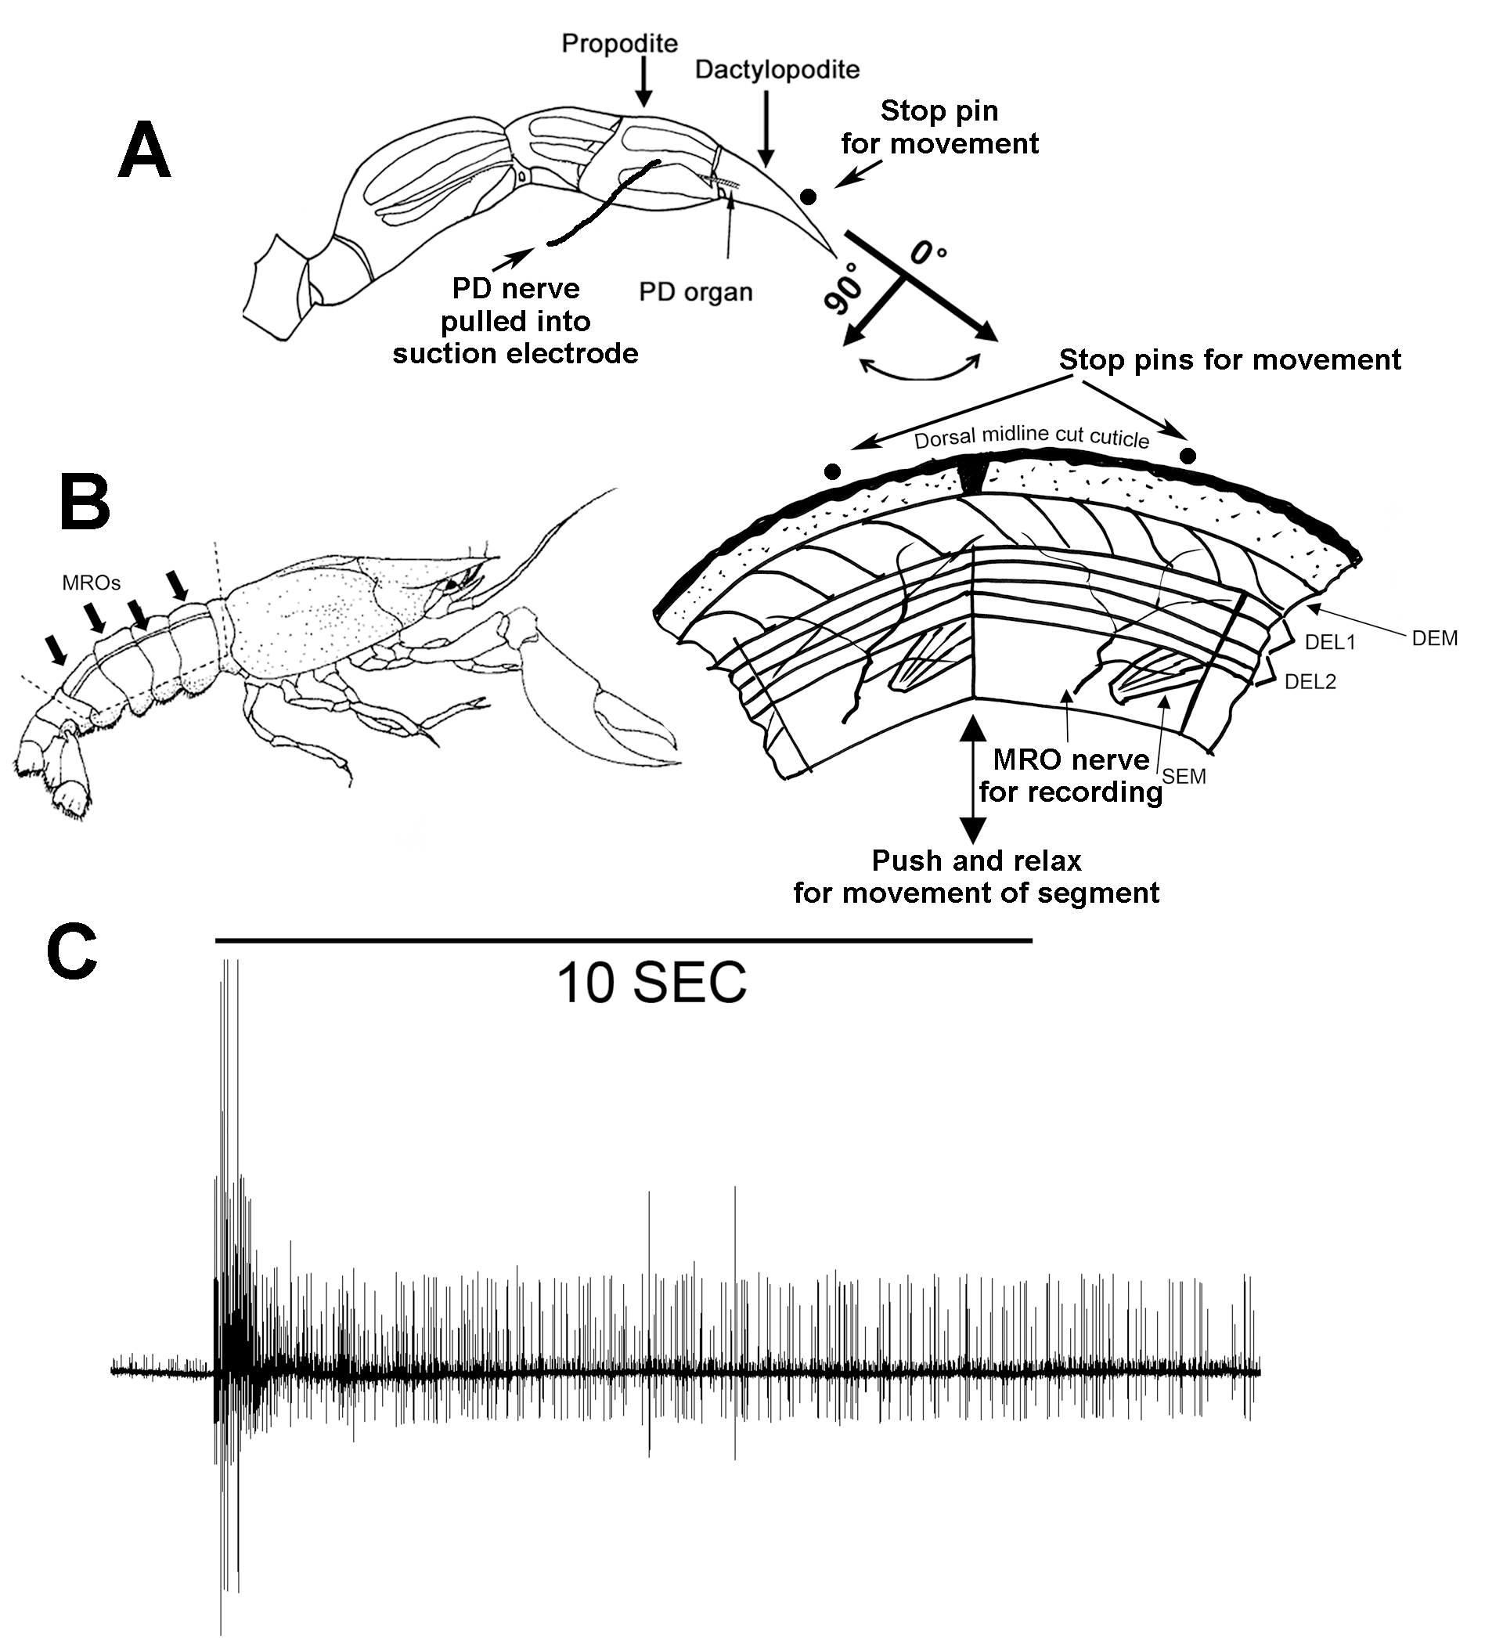

Figure 1. The anatomical location and range of displacements for the crab PD and crayfish MRO proprioceptors. (A) A schematic representation of the 1st walking leg of a crab with the PD organ highlighted in the distal most segments. An insect dissecting pin is placed at the 0-degree location so the distal segment is moved to the same position. Rates of displacement for the crab joint were 1 second to the pin and then held for at least 9 seconds in a static position. The joint was held initially at 90-degree and fully extended to 0-degree. (B) The anatomical location and range of displacements for the MRO organ in the crayfish abdomen. Insect dissecting pins were placed at a set location for maximal displacement of bending the joint to the same position. Rates of displacement for the segment were 1 second and held in a static position for at least 9 seconds. The joint was held initially at an extended position and then bent to the stop pins for consistency. Anatomical drawing is the same shown in Dayaram et al. (2017a). The particular muscles identified: deep extensor medial (DEM) muscles have a spiral fiber pattern; DEL1 is the first lateral group followed by the DEL2 muscles; the superficial extensor medial muscle (SEM) lies directly dorsal to DEL2. The two MRO muscles are more dorsal to the DEL1. (C) A representative trace of an extracellular recording of a crab PD organ to illustrate the analysis procedure. The number of spikes recorded over the ten seconds from the start of the movement were used for analysis.
A rank sum pairwise test or a sign test was used to compare the differences in responses before and after exchanging solutions. A p≤0.05 is considered as statistically significant. To examine the consistency and reproducibility of the effects, experiments were also conducted with a teaching lab in neurophysiology where the students in this class were blind to the agents they were testing.
Web-based Blast
For the first pass search of PIEZO genes in crustaceans, the web-based blast tools were used. The full genetic region of the PIEZO1 genes (see below) was run against NCBI housed crustacean genomes Parhyale hawaiensis, and Eriocheir sinensis (Song et al 2016, NCBI 1988, Kao et al 2016). The blastn and tblastx programs were used for these searches.
Crustacean genomes
Three crustacean genomes were acquired from the National Center for Biotechnology Information webpage, Trinorchestia longiramus, Procambarus virginalis, and Eulimnadia texana (Gutekunst, 2018, NCBI – Presubmission 2019, Baldwin-Brown et al., 2018).
PIEZO gene
PIEZO1 gene sequences from Drosophila melanogaster were acquired from FlyBase database (Thurmond et al., 2019). The gene ID for the full genic region is FBgn0264953, and the ID for the CDS is FBpp0312565. The human PIEZO1 gene sequence was also acquired from NCBI for the initial Web-based blast searches (NCBI 1988).
Alignments
BLAST executables from the BLAST+ 2.6.0 version were downloaded from the NCBI BLAST webpage. The “makeblastdb” command was used to create BLAST databases from the various crustacean genomes acquired. A tblastx local alignment search was run between each genome database and the PIEZO1 sequence file. The following is an example of the code used to generate alignments (Camacho et al., 2008): ncbi-blast-2.6.0+/bin/tblastx -query FlyBase_RVNHFM.fasta -db amiphod -out PIEZO-amiphod -outfmt 6.
Blasts were done between both the full genic region and the CDS region of the PIEZO1 gene. All alignments were completed on the Dell High Performance Cluster that is available for use by researchers through the University of Kentucky Center for Computational Sciences.
Analysis of alignments
Alignment outfiles were assessed by percent identity, alignment length and e-value. A cutoff value of 1e⁻³⁶ for expected value was used.
Results
Responses of the crab PD organ to pharmacological agents
After incubation for 10 minutes in streptomycin (1 mM), the average number of spikes during the ten second displacement periods for the crab PD organ is shown in Figure 2A1. Each data point is an average number of spikes after three displacements in each condition. The percent change among the six preparations revealed no significant effects due to streptomycin Figure 2A2. Likewise, there were no significant changes noted from saline to DMSO (solvent), from DMSO to YODA (Figure 2B1), DMSO to JEDI (Figure 2C1), or DMSO to OB-1 (Figure 2D1). The percent changes (+/-SEM) for each compound illustrate the large variation among the six preparations for saline to DMSO and DMSO to each compound: YODA (Figure 2B2), JEDI (Figure 2C2), and OB-1 (Figure 2D2).

Figure 2. The effects of various compounds on the activity of the crab PD organ. (A1) The average number of spikes from three displacements in saline followed by exposure to streptomycin and an additional three displacements. (A2) The average percent changes (+/- SEM) for the six preparations shown in A1. (B1) The average number of spikes from three displacements in saline followed by exposure to DMSO (three more displacements) and then exposure to YODA (three more displacements). (B2) The average percent changes (+/- SEM) for the six preparations shown in B1. (C1) The average number of spikes from three displacements in saline followed by exposure to DMSO (three more displacements) and then JEDI (three more displacements). (C2) The average percent changes (+/- SEM) for the six preparations shown in C1. (D1) The average number of spikes from three displacements in saline followed by exposure to DMSO (three more displacements) and then OB-1 (three more displacements). (D2) The average percent changes (+/- SEM) for the six preparations shown in D1. YODA, JEDI, and OB-1 all at 48 µM dissolved in the same concentration of DMSO use in the saline containing DMSO trails.
Responses of the crayfish MRO to pharmacological agents
The average number of spikes for the crayfish MRO within the ten seconds of displacement and held static was initially analyzed for the activity over the full 10 seconds. Since the activity in a number of preparations was noted to change for exposure to DMSO and to the pharmacological agents, the data was reanalyzed accounting for the initial 1 second movement (dynamic activity) and the remaining 9 seconds of the preparation held in a static position. The neural activity is presented for the 1 second period and the following 9 seconds for the MRO preparation.
In saline and after 10-minute incubation in streptomycin (1 mM), the responses are shown in Figure 3A. Each data point is an average number of spikes after three displacements in each condition. The percent change among the six preparations revealed no significant effects due to streptomycin Figure 3B.
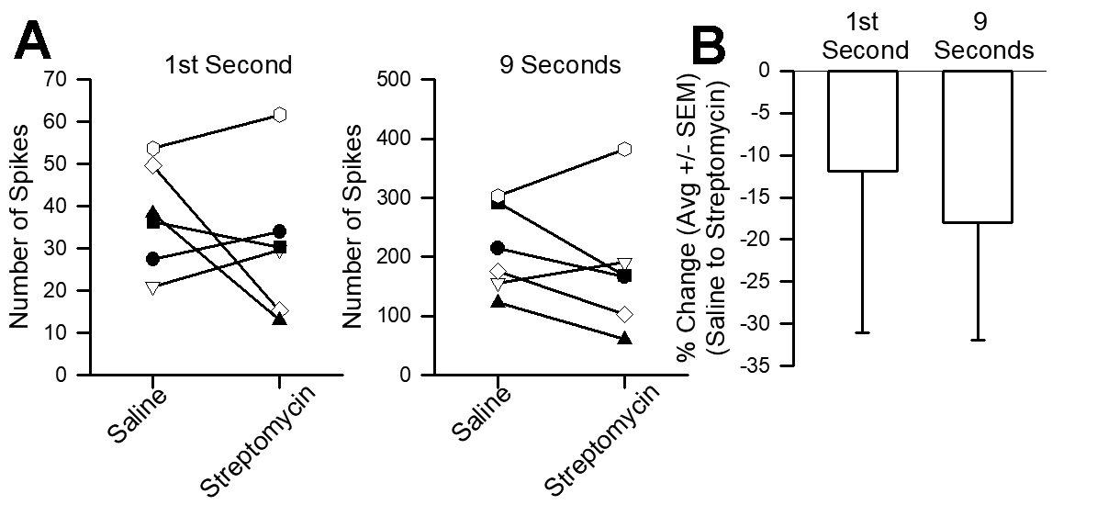
Figure 3. The effects of streptomycin on the activity of the crayfish MRO. (A) The average number of spikes from three displacement in saline followed by exposure to streptomycin and an additional three displacements. (B) The average percent changes (+/- SEM) for the six preparations shown in A.
There was a significant change noted for the change from saline to DMSO (solvent) (p<0.05, Non-parametric Sign test; Figure 4A) in both the 1 second and 9 second responses, but no further significant effect was noted after exposing the preparations to YODA (Figure 4A). There was also a significant effect from saline to DMSO for the 9 second data set for experimental paradigms for the JEDI (Figure 4B). There was a significant change from DMSO to JEDI (p<0.05, Non-parametric Sign test; Figure 4B) for both the 1 second and 9 second responses. In conducting the experiments for the OB-1 the DMSO did not consistently show an effect on the neural activity (Figure 4C), but upon exchange to OB-1 compound only the 9 second activity profile showed a significant effect (p<0.05, Non-parametric Sign test). The percent changes (+/-SEM) for each compound illustrates the large variation among the six preparations from saline to DMSO and from DMSO to each compound: YODA (Figure 4A2), JEDI (Figure 4B2), and OB-1 (Figure 4C2).

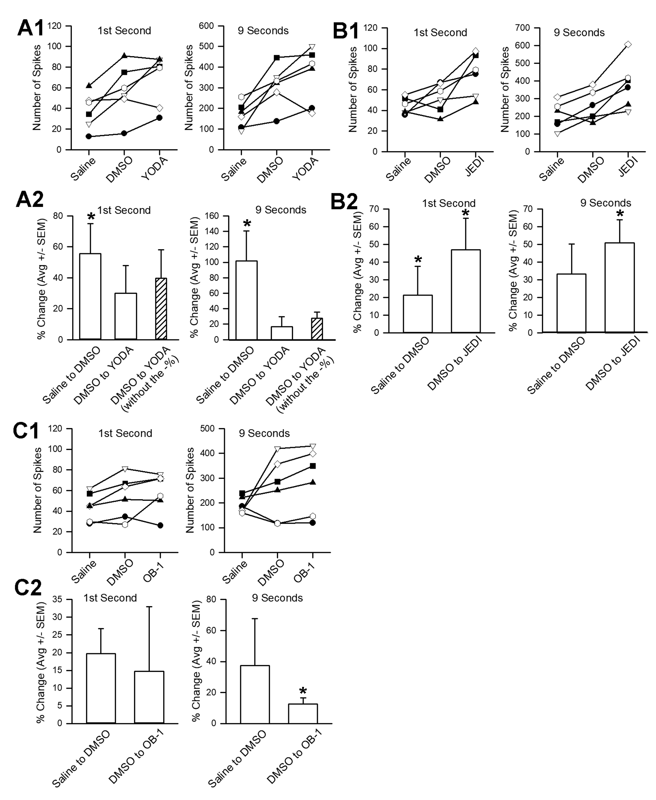

Figure 4. The effects of various compounds on the activity of the crayfish MRO. (A1) The average number of spikes from three displacements in saline followed by exposure to DMSO (three displacements) and then exposure to YODA (three more displacements). (A2) The average percent changes (+/- SEM) for the six preparations shown in A1. Since the one preparation, indicated with the diamond symbol, appeared to show some potential run down over time, the percent change was again calculated without that preparation included for the 1 second and 9 second displacement (hatched bars). Removing that preparation from the overall percent changed did not influence the mean from the other 5 preparations. (B1) The average number of spikes from three displacements in saline followed by exposure to DMSO (three displacements) and then exposure to JEDI (three more displacements). (B2) The average percent changes (+/- SEM) for the six preparations shown in B1. (C1) The average number of spikes from three displacements in saline followed by exposure to DMSO (three displacements) and then exposure to OB-1 (three more displacements). (C2) The average percent changes (+/- SEM) for the six preparations shown in C1. YODA, JEDI, and OB-1 all at 48 µM. The preparations which showed a significant trend based on the Non-parametric Sign test (p<0.05) are indicated with an asterisk.
Since it was recently established that DOOKU can antagonize the effect of YODA on rings of the mouse aorta (Evans et al., 2018), the pharmacological agent was also applied to the crayfish MRO to determine if the effects of YODA could be blocked by DOOKU in this model. In this set of experiments, DOOKU was used at a 5 times higher concentration (250 µM) than YODA (48 µM) as performed in Evans et al., (2018). The activity of six MRO preparations were first examined through three displacements in saline and then three in DMSO, as conducted previously. The DOOKU was then examined on its own (an additional three displacements) before then combining DOOKU and YODA (three more displacements). Each exposure was again incubated for 10 minutes prior to stretching the MRO, aside from the saline prep. It should be noted that the DOOKU was hard to dissolve in DMSO at such a high concentration and though forty microliters of DMSO were used, there were still a few crystals observed once the DOOKU and DMSO mixture was added to 20 ml of crayfish saline. This same dissolving issue was also present for the combined DOOKU and YODA solutions. Additionally, the DMSO control exposures were prepared with 40 µl DMSO placed in 20 ml of saline for these preparations. For the DOOKU aspect of the crayfish preparations, the same analysis was performed as mentioned above, with an average of 3 trials in each condition (i.e., saline, DMSO, DOOKU, DOOKU combined with YODA) after the 10 minute incubation times (Figure 5). There was no effect by DMSO, DOOKU and the combination of DOOKU and YODA for 1 second displacements and the 9 seconds for DMSO and DOOKU. However, the 9 second combined DOOKU and YODA showed a significant decrease from DOOKU alone (Figure 5). This is suggestive that DOOKU combined with YODA decreases overall activity for the static sensitive proprioceptive SACs of the crayfish MRO.
The exposure to DMSO alone produced varied responses among the preparations for the crab PD and crayfish MRO preparations. In the PD preparations, the variability is large among preparations examined for the DMSO alone where some preparations increased activity and others decreased in activity. In combining all the data sets to examine a before and after effect to DMSO there was no statistical significant effect due to exposure of DMSO (Paired-T test, N=18; figure 2). However, in combining all data sets for the MRO preparations among each displacement measure (1 second dynamic movement and 9 second static held displacement), to examine a before and after effect to DMSO, there was a statistical significant effect of DMSO increasing activity for the 1 second displacement (P = <0.001, Paired T-test, N=24; Figures 4 and 5) and for the 9 second static held position (P = 0.007, Paired T-test, N=24; Figures 4 and 5). In comparing the effect of DMSO among the different groups of compounds examined there as statistically significant difference for saline to DMSO between the YODA and JEDI groups for the 9 second data sets but not the 1 second data sets (not normal distributed, Kruskal-Wallis one way analysis of variance on ranks, P = 0.046; N=6 in each group).

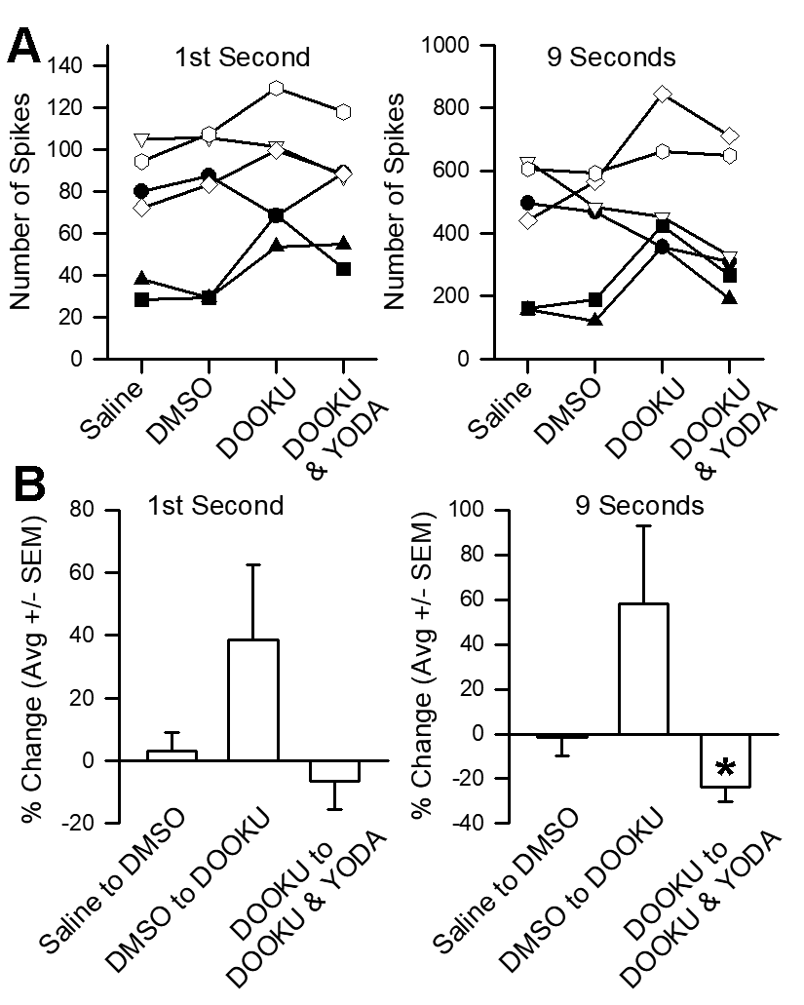
Figure 5. The effect of DOOKU on YODA's response on the crayfish MRO. (A) The six trials showed varied responses to DOOKU; however, the combination of DOOKU and YODA decreased overall activity in all six preparations. (B) The percent change from saline to DMSO and from DMSO to DOOKU both showed no significant effects. However, the exposure to the combination of DOOKU and YODA did result in a significant decrease of overall neural activity for the 9 seconds of static sensitive responses, but not for the rapid dynamic neurons (1 second). The Non-parametric Sign test p<0.05 is indicated with an asterisk. DOOKU (250 µM) and YODA (48 µM).

Effect on muscle membrane potential
Since the crayfish MRO preparation showed the application of DMSO to have some effect (and some of the pharmacological agents) there’s potential that the biophysical properties of the muscle fibers were altered, which then resulted in tension on the sensory endings embedded in the fibers. One approach to address this possibility was to examine the resting membrane potential in muscle fibers. However, the two very thin muscle fibers associated with the MRO are challenging to maintain prolonged intracellular recordings due to the suspended nature between the abdominal segments. Thus, the distal muscle fibers in the opener muscle in the walking legs of the crayfish were used for assessment. These muscle fibers are well supported by neighboring fibers for long term monitoring of the resting membrane potential. There was no significant effect from the saline containing the same concentration of DMSO or concentration of combined DMSO and YODA, as used to assess action on the MRO preparations (Table 1).
 | RP Saline | RP DMSO + YODA | RP DMSO
Prep. 1 | -61 RP | - 61 RP | - 61 RP
Prep. 2 | -73 RP | - 71 RP | - 70 RP
Prep. 3 | -68 RP | - 69 RP | - 68 RP
Prep. 4 | -76 RP | - 75 RP | - 74 RP
Prep. 5 | -66 RP | - 68 RP | - 65 RP
Prep. 6 | -77 RP | -75 RP | -74 RP

Table 1: Resting membrane potentials (mV) after 10 minutes
in each condition. Crayfish walking leg opener muscle.

Genomic comparison
Five crustacean genomes were surveyed; mangrove amphipod (Parhyale hawaiensis), Chinese mitten crab (Eriocheir sinensis), sand-hopper (Trinorchestia longiramus), marbled crayfish (Procambarus virginalis), Texas clam shrimp (Eulimnadia texana) for homologs of the PIEZO 1 gene. The focus was on the PIEZO 1 gene comparison as the pharmacological agents tested in this study are known to be specific for the PIEZO 1 stretch activated channels (Wang et al., 2018). Initially, web-based blasts were performed using the human and fruit fly PIEZO1 gene sequences to search the mangrove amphipod and Chinese mitten crab genomes. There were no significant hits in terms of query cover, e-value, or percent identity for either species. It is worth noting that consistent hits to two small regions of the PIEZO 1 gene were shown in the human to Chinese mitten crab comparison.
Upon these results the search was expanded to include the sand-hopper, the marbled crayfish, and the Texas clam shrimp genomes, and blast executables were run locally. Full genic and CDS sequences of the fruit fly PIEZO 1 gene were used in these searches, and final outputs were analyzed for significant hits. For the sand-hopper and the Texas clam shrimp, there were no significant results when using the CDS sequence. For the marbled crayfish, there were short hits with e-values of 4.69e⁻¹⁷⁴ to the scaffold MRZY010015166.1, when using the CDS sequence. For the full genic sequence there were hits with e-values of 1.98e⁻¹⁹⁸ for the marbled crayfish to the scaffold MRZY010015166.1. There were also hits from the sand-hopper to the KV721777.1 scaffold with e-values 1.16e⁻¹⁷⁶. For all of these hits the alignment lengths were about 60bp or under, which lends towards low confidence in their significance.
Discussion
The crab PD organ and crayfish MRO are robust preparations in neural activity and maintain neural activity and reproducibility to joint movements well for hours at room temperature in minimal physiological salines. This is one reason they are good preparations for educational models in neurophysiology laboratories. In addition, they are good models when it is required to incubate pharmacological agents as they are so hardy for short multiple incubation periods. Thus, if a pharmacological compound is to have an effect on the exposed sensory endings one would likely be able to observe changes in activity. The crab PD preparation did not show a significant trend in altered evoked activity to streptomycin, YODA, JEDI, or OB 1. However, the crayfish MRO did show an increase in evoked activity in the presence of JEDI as well as showing a reduced activity of YODA when pre-incubated with DOOKU. The results from our genomic search for PIEZO1 homologs within multiple crustacean genomes, including crayfish species, indicate possible an absence of PIEZO1 genes from these genomes. Thus, one would not expect a high pharmacological similarity to the SACs for PIEZO 1.
The chordotonal organs in leg segments of crabs and in insects anatomically are very similar with movement and static position sensitivity of the primary sensory endings within the elastic strands. The sensory endings having a scolopale cap over them and the action potentials are initiated close to these endings (Mendelson, 1963; Hartman and Boettiger, 1967; Whitear, 1962). Thus, it is likely the SACs are located within the scolopidium. Likewise for the crab, it would appear bathing the PD preparation for 10 minutes would suffice for the agents tested to gain access to the SACs in the sensory endings since Gd³⁺ was able to gain access which rapidly blocked the SACs in an earlier study (Dayaram et al., 2017b). Whereas the sensory ending of the MRO are free endings embedded within the muscle fibers (Elekes and Florey, 1987; Eyzaguirre and Kuffler, 1955). These sensory endings are also fairly accessible to compounds added to the bathing saline as Gd³⁺ was able to rapidly block the SACs and be removed quickly with exchanging the bathing media (Dayaram et al., 2017b). Given that the sensory endings of the MRO directly monitor the stretching forces on the muscle, if the compounds increase the stiffness or even promote contraction of the muscle fibers themselves then there would be an alteration on the sensory activity even though there was no direct action of the compounds on the SACs within the sensory endings. One might be able to damage the muscle fibers in regions not associated with the sensory endings and wash away the cellular debris to isolate sensory ends and apply pressure to examine direct effects of compounds on the SACs, but this has not been accomplished to date. However, this intact muscle and sensory ending generally mimics the function of the mammalian muscle spindle so studying the function of the whole unit is a better comparison to the mammalian muscle spindle.
Since the pharmacological compounds YODA, JEDI, OB 1 and DOOKU were not soluble in saline they had to be first dissolved in DMSO and then saline. Thus, the effect of DMSO in saline without the agents was examined. The exposure to DMSO produced varied responses for the PD organ without a significant trend; however, DMSO produced an enhance activity on the MRO preparations. Since the sensory neurons for the MRO are embedded in the muscle fibers we assumed the muscle might have depolarized and added tension of the sensory endings. The examination of the membrane potentials for the opener muscle upon exposure of DMSO did not support this concern. In speculation, maybe the muscle become more ridged without depolarization so when it was stretched a larger effect on the sensory endings was produced. Alternatively, DMSO may have had a direct effect on the neuronal properties for the crayfish neurons as compared to the crab preparations. Not considering the effect of DMSO, but the overall variability of the responses for the PD or MRO preparations may also be inherent among the neurons themselves. Previous recordings of single neurons in chordotonal organs of the crab leg did reveal that some neurons were consistent in their responses and others were not to the same displacements (Cooper and Hartman, 1999). Such detailed analysis in variability of responses has not yet been performed on the crayfish MRO or the crab PD organ at a level of single neurons.
It is possible the SACs are of a different subtype in the crayfish MRO as compared to the chordotonal organs of crabs. However, no pharmacological profiles have yet been able to classify the SACs in these sensory neurons. Just as important are findings which determine compounds that do not have an action on SACs as then this helps in the process of elimination of receptor subtypes. In some preparations, OB-1 can inhibit the PIEZO 1 subtype. The membrane of the cultured mouse neuroblastoma cell line (Neuro2A or N2a) expressing Piezo 1 channels was displaced ranging from 100 to 1,000 nm, and both OB-1 and OB-2 reduced the sensitivity of mechanosensitive currents (Wetzel et al., 2017). The action potential amplitudes were not affected in these cells by OB-1 and OB-2 compounds (Wetzel et al., 2017).
Even if genomic or protein identification was available for the SACs in these crab and crayfish preparations, it would still be important to screen pharmacological agents assumed to have an action. Considering the five subunits forming the postsynaptic receptors at the Drosophila neuromuscular junction were deemed to be similar in genomic homology to kainate receptors in vertebrates, they were termed kainate-like (Qin et al., 2005). However, the application of the kainate has no physiological action at the larval Drosophila NMJ (Bhatt and Cooper, 2005; Lee et al., 2009). Thus, one should be cautious to define receptors on pharmacological terms based on genomic comparisons until they are also physiologically screened.
Genomic, mRNA and protein isolation comparisons among species are also important means in identifying the types of SACs possible. Once knowing if a subtype is even possible from genomic analysis it is of interest to determine which tissues express the SACs of interest. From the bioinformatic scanning of multiple crustacean genomes for PIEZO 1 it is unlikely that this SAC subtype is present in crustaceans. Future studies are underway to scan these genomes for other SAC possible in crabs and crayfish so further identification at a cell level can be made in the cellular expression and localization. Future studies could address various concentrations of these pharmacological agents; however, the 48 µM concentration used in this study is a concentration used in other studies which had shown substantial effects for PIEZO 2 subtype of SACs. It would also be of interest to know if the activity would be able to return to the initial levels by removing the compounds when exchanging the bathing saline. Potentially, the DMSO or the compounds themselves may have long term effects not able to be readily reversed.
Acknowledgements
We thank Dr. Eve Schneider at the University of Kentucky for suggesting to try the various compounds in this study on these preparations. We thank the Bio446 Neurophysiology class for also testing some of the compounds used in this study on the crab PD organ. The participants were Stanley, C.E., Campbell, K., Adams, R., Nadolski, J., Amrit, E., Barrett, M., Bohnett, C., Deweese, K., Dhar, S., Gillis, B., Hill, C., Inks, M., Kozak, K., Larson, A., Murtaza, I., Nichols, D., Roberts, R., Tyger, H.
Funding
This work was supported by the Department of Biology, University of Kentucky for the Bio446 neurophysiology teaching laboratory and by personal funds (RLC).
References
Arnadóttir, J., Chalfie, M., 2010. Eukaryotic mechanosensitive channels. Annu. Rev. Biophys. 39, 111-137. doi: 10.1146/annurev.biophys.37.032807.125836.
Bae, C., Sachs, F., Gottlieb, P.A., 2011. The mechanosensitive ion channel PIEZO1 is inhibited by the peptide GsMTx4. Biochem. 50(29), 6295-300. doi: 10.1021/bi200770q.
Baldwin-Brown, J.G., Weeks, S.C., Long, A.D., 2018. A new standard for crustacean genomes: the highly contiguous, annotated genome assembly of the clam shrimp Eulimnadia texana reveals hox gene order and identifies the sex chromosome. Genome Biol. Evol. 10(1), 143–156. doi:10.1093/gbe/evx280
Bhatt, D., Cooper, R.L. 2005. The pharmacological and physiological profile of glutamate receptors at the Drosophila larval neuromuscular junction. Physiol. Entomol. 30, 205-210.
Boscardin, E., Alijevic, O., Hummler, E., Frateschi, S., Kellenberger, S., 2016. The function and regulation of acid-sensing ion channels (ASICs) and the epithelial Na(+) channel (ENaC): IUPHAR Review 19. Br. J. Pharmacol. 173(18), 2671-2701. doi: 10.1111/bph.13533.
Burke, W., 1953. An organ for proprioception and vibration sense in Carcinus maenas. J. Exp. Biol. 31, 127-138.
Camacho, C., Coulouris, G., Avagyan, V., Ma, N., Papadopoulos, J., Bealer K., Madden T.L., 2008. BLAST+: architecture and applications. BMC Bioinformatics 10, 421.
Chesler, A.T., Szczot, M., Bharucha-Goebel, D., Čeko, M., Donkervoort, S., Laubacher, C., Hayes, L.H., Alter, K., Zampieri, C., Stanley, C., Innes, A.M., Mah, J.K., Grosmann, C.M., Bradley, N., Nguyen, D., Foley, A.R., Le Pichon, C.E., Bönnemann, C.G., 2016. The role of PIEZO2 in human mechanosensation. N. Engl. J. Med. 375(14),1355-1364.
Cooper, A.S., Cooper, R.L., 2009. Historical view and physiologydemonstration at the
NMJ of the crayfish opener muscle. J. Vis. Exp. 33, e1595. DOI: https://doi.org/10.3791/1595.

Cooper, R.L., Hartman, H.B., 1999. Quantification of responses from proprioceptive
neurons in the limbs of the crab, Cancer magister. J. Exp. Zool. 284, 629-636.

Coste, B., Mathur, J., Schmidt, M., Earley, T.J., Ranade, S., Petrus, M.J., Dubin, A.E., Patapoutian, A., 2010. Piezo1 and Piezo2 are essential components of distinct mechanically activated cation channels. Science. 330, 55–60.
Dayaram, V., Malloy, C., Martha, S., Alvarez, B., Chukwudolue, I., Dabbain, N., D.mahmood, D., Goleva, S., Hickey, T., Ho, A., King, M., Kington, P., Mattingly, M., Potter, S., Simpson, L., Spence, A., Uradu, H., Van Doorn, J.L., Cooper, R.L., 2017a. The effect of CO2, intracellular pH and extracellular pH on mechanosensory proprioceptor responses in crayfish and crab. Am. J. Undergraduate Res. 14(3), 85-99.
Dayaram, V., Malloy, C., Martha, S., Alvarez, B., Chukwudolue, I., Dabbain, N., D.mahmood, D., Goleva, S., Hickey, T., Ho, A., King, M., Kington, P., Mattingly, M., Potter, S., Simpson, L., Spence, A., Uradu, H., Van Doorn, J.L., Cooper, R.L., 2017b. Stretch activated channels in proprioceptive chordotonal organs of crab and crayfish are sensitive to Gd3+ but not amiloride, ruthenium red or low pH. IMPLUSE The Premier Undergraduate Neuroscience Journal. https://impulse.appstate.edu/issues/2017
Elekes, K., Florey, E. 1987. New types of synaptic connections in crayfish stretch receptor organs: an electron microscopic study. J. Neurocytol. 16, 613-626.
Ernstrom, G.G., Chalfie, M., 2002. Genetics of sensory mechanotransduction. Annu. Rev. Genet. 36, 411-453.
Evans, E.L., Cuthbertson, K., Endesh, N., Rode, B., Blythe, N.M., Hyman, A.J., Hall, S.J., Gaunt, H.J., Ludlow, M.J., Foster, R., Beech, D.J., 2018. YODA1 analogue (DOOKU1) which antagonizes YODA1-evoked activation of PIEZO1 and aortic relaxation. Br. J. Pharmacol. 175(10), 1744-1759. doi: 10.1111/bph.14188.
Eyzaguirre, C. Kuffler, S.W., 1955. Processes of excitation in the dendrites and in the soma of single isolated sensory nerve cells of the lobster and crayfish. J. Gen. Physiol. 39, 87–119.
Frantsevich, L., Shumakova, I., Gladun, D., 2019. Mechanical and optical properties of the femoral chordotonal organ in beetles (Coleoptera). J. Exp. Biol. 222(Pt 21). pii: jeb203968. doi: 10.1242/jeb.203968.
Geffeney, S.L., Goodman, M.B., 2012. How we feel: ion channel partnerships that detect mechanical inputs and give rise to touch and pain perception. Neuron. 74(4), 609-619. doi: 10.1016/j.neuron.2012.04.023.
Göpfert, M.C., Hennig, R.M., 2016. Hearing in insects. Annu. Rev. Entomol. 61, 257-276. doi: 10.1146/annurev-ento-010715-023631
Goralczyk, A., van Vijven, M., Koch, M., Badowski, C., Yassin, M.S., Toh, S.A., Shabbir, A., Franco-Obregón, A., Raghunath, M., 2017. TRP channels in brown and white adipogenesis from human progenitors: new therapeutic targets and the caveats associated with the common antibiotic, streptomycin. FASEB J. 31(8), 3251-3266. doi: 10.1096/fj.201601081RR.
Gutekunst, J., Andriantsoa, R., Falckenhayn, C., Hanna, K., Stein, W., Rasamy, J., Lyko, F., 2018. Clonal genome evolution and rapid invasive spread of the marbled crayfish. Nat. Ecol. Evol. 2, 567–573. doi:10.1038/s41559-018-0467-9
Hartman, H.B., Boettiger, E.G., 1967. The functional organization of the propys-dactylus organ in Cancer irroratus Say. Comp. Biochem. Physiol. 22, 651-663.
Kao, D., Lai, A. G., Stamataki, E., Rosic, S., Konstantinides, N., Jarvis, E., Di Donfrancesco, A., Pouchkina-Stancheva, N., Sémon, M., Grillo, M., Bruce, H., Kumar, S., Siwanowicz, I., Le, A., Lemire, A., Eisen, M.B., Extavour, C., Browne, W.E., Wolff, C., Averof, M., Patel, N.H., Sarkies, P. Pavlopoulos, A., Aboobaker, A., 2016. The genome of the crustacean Parhyale hawaiensis, a model for animal development, regeneration, immunity and lignocellulose digestion. eLife, 5, e20062. doi:10.7554/eLife.20062
Kuffler, S.W., 1954. Mechanisms of activation and motor control of stretch receptors in lobster and crayfish. J. Neurophysiol. 17, 558-574.
Lee, J.-Y., Bhatt, D., Bhatt, D., Chung, W.-Y., and Cooper, R.L., 2009. Furthering pharmacological and physiological assessment of the glutamatergic receptors at the Drosophila neuromuscular junction. Comp. Biochem. Physiol. C 150, 546–557.
Leksrisawat, B., Cooper, A.S., Gilberts, A.B., Cooper, R.L., 2010. Muscle receptor organs in the crayfish abdomen: a student laboratory exercise in proprioception. J. Vis. Exp. 45, e2323.
Majeed, Z.R., Titlow, J., Hartman, H.B., Cooper, R.L., 2013. Proprioception and Tension Receptors in Crab Limbs: Student Laboratory Exercises. J. Vis. Exp. 80, e51050, doi:10.3791/51050.
Malloy, C., Dayaram,V., Martha, S., Alvarez, B., Chukwudolue, I., Dabbain, N., D.mahmood, D., Goleva, S., Hickey, T., Ho, A., King, M., Kington, P., Mattingly, M., Potter, S., Simpson, L., Spence, A., Uradu, H., Van Doorn, J.L., Weineck, K., Cooper, R.L., 2017. The effects of neighboring muscle injury on proprioception responses in crayfish and crab. J. Exp. Zoology. 327(6), 366–379.
Mendelson, M., 1963. Some factors in the activation of crab movement receptors. J. Exp. Biol. 40, 157-169.
Mikhailov, N., Leskinen, J., Fagerlund, I., Poguzhelskaya, E., Giniatullina, R., Gafurov, O., Malm, T., Karjalainen, T., Gröhn, O., Giniatullin, R., 2019. Mechanosensitive meningeal nociception via PIEZO channels: Implications for pulsatile pain in migraine? Neuropharmacol. 149, 113-123. doi: 10.1016/j.neuropharm.2019.02.015
National Center for Biotechnology Information (NCBI)[Internet]. Bethesda (MD): National Library of Medicine (US), National Center for Biotechnology Information; [1988] – [cited 2017 Apr 06]. Available from: https://www.ncbi.nlm.nih.gov/
Omerbašić, D., Schuhmacher, L.N., Bernal Sierra, Y.A., Smith, E.S., Lewin, G.R., 2015. ASICs and mammalian mechanoreceptor function. Neuropharmacol. 94, 80-86. doi: 10.1016/j.neuropharm.2014.12.007.
Qin, G., Schwarz, T., Kittel, R.J., Schmid, A., Rasse, T.M., Kappei, D., Ponimaskin, E., Heckmann, M., Sigrist, S.J., 2005. Four different subunits are essential for expressing the synaptic glutamate receptor at neuromuscular junctions of Drosophila. J. Neurosci. 25, 3209–3218.
Rydqvist, B., Lin, J.H., Sand, P., Swerup, C., 2007. Mechanotransduction and the crayfish stretch receptor. Physiol. Behav. 92(1-2), 21-28.
Song, L., Bian, C., Luo, Y., Wang, L., You, X., Li, J., Qiu, Y., Ma, X., Zhu, Z., Ma, L., Wang, Z., Lei, Y., Qiang, J., Li, H., Yu, J., Wong, A., Xu, J., Shi, Q., Xu, P., 2016. Draft genome of the Chinese mitten crab, Eriocheir sinensis. GigaScience, 5, 5. doi:10.1186/s13742-016-0112-y
Sparks, G., Cooper, R.L., 2004. 5-HT offsets homeostasis of synaptic transmission during short-term facilitation. J. Appl. Physiol. 96, 1681–1690.

Stanback, M., Stanback, A.E., Akhtar, S., Basham, R., Chithrala, B., Collis, B., Heberle, B.A., Higgins, E., Lane, A., Marella, S., Ponder, M., Raichur, P., Silverstein, A., Stanley, C., Vela, K., Cooper, R.L., 2019. The effect of lipopolysaccharides on primary sensory neurons in crustacean models. IMPLUSE https://impulse.appstate.edu/articles/2019/effect-lipopolysaccharides-primary-sensory-neurons-crustacean-models
Strauß, J., 2017. The scolopidial accessory organs and Nebenorgans in orthopteroid insects: Comparative neuroanatomy, mechanosensory function, and evolutionary origin. Arthropod Struct. Dev. 46(6), 765-776. doi: 10.1016/j.asd.2017.08.004
Suslak, T.J., Watson, S., Thompson, K.J., Shenton, F.C., Bewick, G.S., Armstrong, J.D., Jarman, A.P., 2015. Piezo is essential for amiloride-sensitive stretch-activated mechanotransduction in larval Drosophila dorsal bipolar dendritic sensory neurons. PLoS One. 10(7), e0130969. doi: 10.1371/journal.pone.0130969. eCollection 2015.
Swerup, C., Rydqvist, B., 1992. The abdominal stretch receptor organ of the crayfish. Comp. Biochem. Physiol. A. 103, 433-431.
Syeda, R., Xu, J., Dubin, A.E., Coste, B., Mathur, J., Huynh, T., Matzen, J., Lao, J., Tully, D.C., Engels, I.H., Petrassi, H.M., Schumacher, A.M., Montal, M., Bandell, M., Patapoutian, A., 2015. Chemical activation of the mechanotransduction channel PIEZO1. ELife 4, e07369.
Thurmond, J., Goodman, J.L., Strelets, V.B., Attrill, H., Gramates, L.S., Marygold, S.J., Matthews, B.B., Millburn, G., Antonazzo, G., Trovisco, V., Kaufman, T.C., Calvi, B.R., the FlyBase Consortium. 2019. FlyBase 2.0: the next generation. Nucleic Acids Res. 47(D1), D759–D765.
Wang, Y., Chi, S., Guo, H., Li, G., Wang, L., Zhao, Q., Rao, Y., Zu, L., He, W., Xiao, B., 2018. A lever-like transduction pathway for long-distance chemical- and mechano-gating of the mechanosensitive PIEZO1 channel. Nat. Commun. 9(1), 1300. doi: 10.1038/s41467-018-03570-9.
Welsh, M.J., Price, M.P., Xie, J., 2002. Biochemical basis of touch perception: mechanosensory function of degenerin/epithelial Na+ channels. J. Biol. Chem. 277(4), 2369-2372.
Wetzel, C., Pifferi, S., Picci, C., Gök, C., Hoffmann, D., Bali, K.K., Lampe, A., Lapatsina, L., Fleischer, R., Smith, E.S., Bégay, V., Moroni, M., Estebanez, L. Kühnemund, J., Walcher, J., Specker, E., Neuenschwander, M., von Kries, J.P., Haucke, V., Kuner, R., Poulet, J.F., Schmoranzer, J., Poole, K., Lewin, G.R., 2017 Small-molecule inhibition of STOML3 oligomerization reverses pathological mechanical hypersensitivity. Nat. Neurosci. 20, 209-218.
Whitear, M., 1960. Chordotonal organs in Crustacea. Nature, London 187, 522-523.
Whitear, M., 1962. The fine structure of crustacean proprioceptors. I. The chordotonal organs in the legs of the shore crab, Carcinus meanas. Philos. Trans. R. Soc. Lond. B Biol. Sci. 245 (725), 291-325.
Whitear, M., 1965. The fine structure of crustacean proprioceptors. II. The thoracico-coxal organs in Carcinus, Pagurus and Astacus. Philos. Trans. R. Soc. Lond. B Biol. Sci. 248 (752), 437-456.
Wiersma, C.A.G., 1959. Movement receptors in decapod crustacea. J. Mar. Biol. Assoc. U.K. 38 (01), 143-152.

